The University of Azad Jammu and Kashmir, Muzaffarbad



Maryam Shaheen
2024-SE-30
Database Systems
Engr.Awais Rathore

Department of Software Engineering

Lab #8

Objective
The objective of this lab is to understand and implement basic SQL joins for combining data from related tables.
In this lab, I worked with INNER JOIN, LEFT JOIN, and RIGHT JOIN to retrieve related information from the Department, Employee, Project, and Assignment tables.
Learning Outcomes
After completing this lab, I was able to:
- Understand the purpose of SQL joins.
- Combine information from two related tables.
- Use INNER JOIN to retrieve matching records.
- Use LEFT JOIN to preserve all records from the left table.
- Use RIGHT JOIN to preserve all records from the right table.
- Find records that do not have a matching relationship.
- Use joins together with WHERE conditions.
- Use GROUP BY and COUNT with LEFT JOIN.
- Understand how a FULL OUTER JOIN can be represented in MySQL using UNION.
Database Used
The lab uses a Company database containing four related tables:
- Department
- Employee
- Project
- Assignment
The Employee table is related to Department through DeptID. The Assignment table connects employees with projects, while the Project table is related to Department.
The database structure is designed with some missing relationships so that different types of joins can be properly demonstrated. For example, one department has no employees, one project has no department, and some employees have no project assignments.

Introduction to SQL Joins
A join is used when information is stored in different tables and needs to be displayed together.
For example, the Employee table contains the department ID but does not directly contain the department name. By joining Employee with Department, I can display an employee's name together with the name and location of the department.
A join normally connects a primary key in one table with a corresponding foreign key in another table.
Types of Joins Used
INNER JOIN
INNER JOIN returns only those records that have matching values in both tables.
It is useful when I only want records that have a valid relationship in both tables.
LEFT JOIN
LEFT JOIN returns all records from the left table. If there is no matching record in the right table, NULL values are displayed.
This is useful when I do not want unmatched records from the main table to be removed.
RIGHT JOIN
RIGHT JOIN returns all records from the right table, even when there is no matching record in the left table.
For example, it can be used to display every department, including departments that currently have no employees.

Part A — INNER, LEFT and RIGHT JOIN
A1. Every employee with department name and location
I used an INNER JOIN to display every employee together with the name and location of their department.
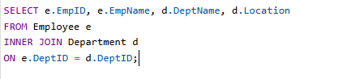
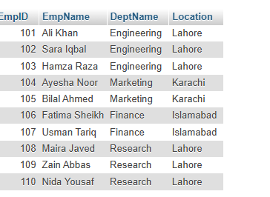

A2. Every employee, including employees with NULL DeptID
I used a LEFT JOIN to display all employees, including employees whose department information is NULL.
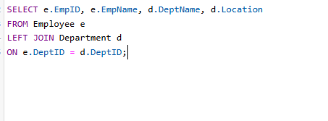
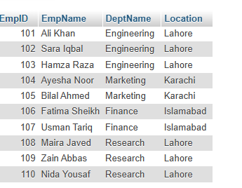
A3. Every department with employee names
I used a RIGHT JOIN to display every department along with the names of its employees.
The department with no employees was also included in the result.

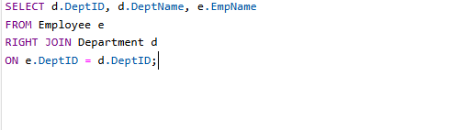
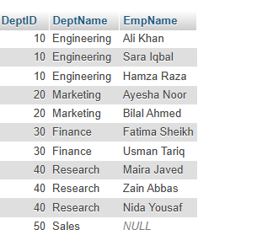
A4. Every project with department name and location
I displayed every project together with its department name and location.
A LEFT JOIN was used so that projects without a department were also included.

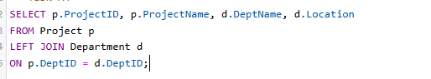

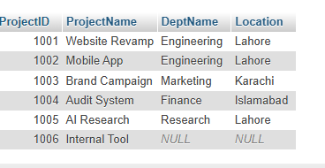
A5. Employees not assigned to any project
I used the LEFT JOIN and IS NULL pattern to identify employees who were not assigned to any project.
This is an example of an anti-join.

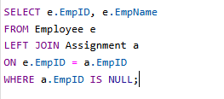
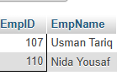
A6. Projects with no assignments
I identified projects that currently have no employees assigned to them.
A LEFT JOIN was used together with an IS NULL condition.

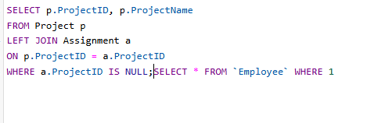
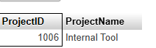
A7. Engineering employees with salary, highest first
I displayed employees working in the Engineering department together with their salaries.
The results were arranged in descending order of salary.

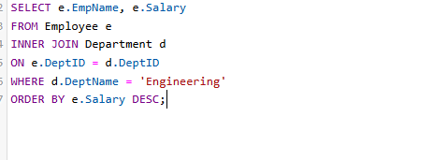
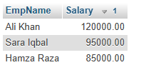
A8. Employees in Lahore-based departments
I displayed the names of employees who belong to departments located in Lahore.
The department name was also displayed.

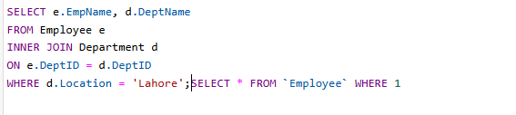
A9. Every department with employee count
I displayed every department and counted the number of employees working in each department.
A LEFT JOIN was used so that departments with zero employees were also displayed.

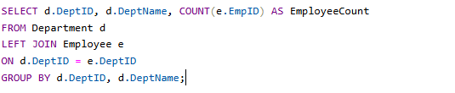
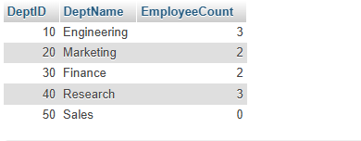
A10. FULL OUTER JOIN using UNION
MySQL does not directly provide a FULL OUTER JOIN.
Therefore, I combined a LEFT JOIN and a RIGHT JOIN using UNION to produce a result containing records from both sides.

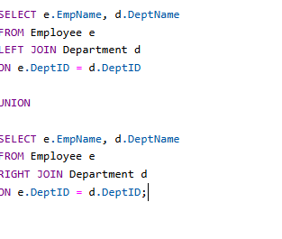
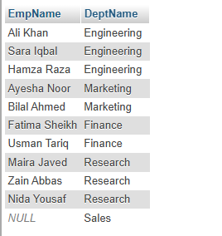
Important Observations
During this lab, I observed that:
- INNER JOIN removes unmatched records.
- LEFT JOIN preserves all records from the left table.
- RIGHT JOIN preserves all records from the right table.
- NULL values appear when no matching record exists.
- LEFT JOIN with IS NULL can be used to find missing relationships.
- LEFT JOIN can be combined with GROUP BY and COUNT.
- FULL OUTER JOIN can be simulated in MySQL using UNION.

Conclusion
In this lab, I learned how to use INNER JOIN, LEFT JOIN, and RIGHT JOIN to combine information from related database tables. I also learned how joins can be used to find missing relationships and how multiple joins can be combined with filtering and aggregation.
The lab helped me understand how normalized database tables can be connected to retrieve meaningful information.

